**PROGRAM**

#include<stdio.h>

#include<conio.h>

#include<string.h>

#include<time.h>

#include<stdlib.h>

void quick_sort(long int *x,int first,int last){

long int pivot,j,temp,i;

if(first<last)

{

pivot=first;

i=first;

j=last;

while(i<j){

while(x[i]<=x[pivot]&&i<last)

i++;

while(x[j]>x[pivot])

j--;

if(i<j){

temp=x[i];

x[i]=x[j];

x[j]=temp;

}

}

**Page 1**

temp=x[pivot];

x[pivot]=x[j];

x[j]=temp;

quick_sort(x,first,j-1);

quick_sort(x,j+1,last);

}

}

int n_ary_search(long int *arr,int beg,int end,int key,int d)

{

long int a[d];

a[0]=beg;

if(beg>end)

{ return -1; }

for(int i=1;i<=d-1;i++)

{ a[i]=beg+ i*(end-beg)/d; }

for(int i=1;i<=d-1;i++)

{

if(arr[a[i]]==key)

{ return 1;}

else if(key<arr[a[i]])

{ n_ary_search(arr,a[i-1],a[i]-1,key,d); }

}

return n_ary_search(arr,a[d-1]+1,end,key,d);

return 0;

}

**Page 2**

int main()

{

long int arr[5000],i,key,j,d,k,l,m,n,count=0;

double sum;

clock_t start,stop;

FILE *fp;

fp=fopen("output1.csv","w");

for(d=2;d<=11;d++)

{

for(n=50;n<=500;n+=50)

{

for(i=0;i<n;i++)

{ arr[i]=rand()%10000;

}

key=rand()%10000;

quick_sort(arr,0,n-1);

for(k=0;k<5000;k++) // to take average

{

start=clock();

n_ary_search(arr,0,n-1,key,d);

stop=clock();

double ans=(double)stop-(double)start;

sum=sum+ans;

}

**Page 3**

printf("\nN=%d and d=%d\n",n,d);

sum=sum/5000.0;

printf("%f\n",sum);// answer for average of 5000 calculations

fprintf(fp,"%f,",sum);

}

fprintf(fp,"\n");

}

fclose(fp);

}

**Page 4**

**OUTPUT WINDOW**

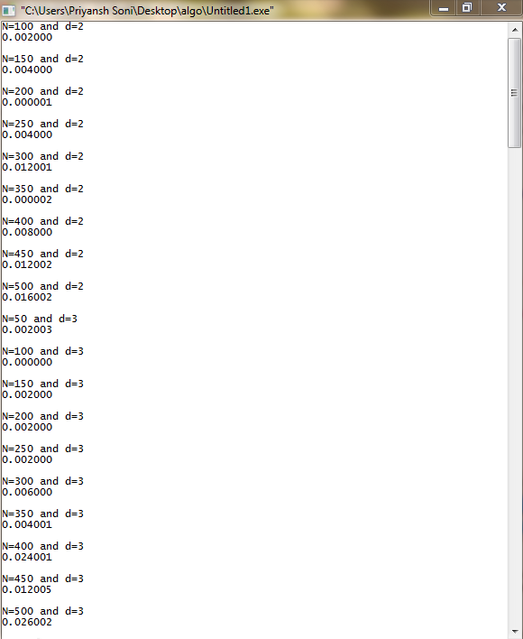

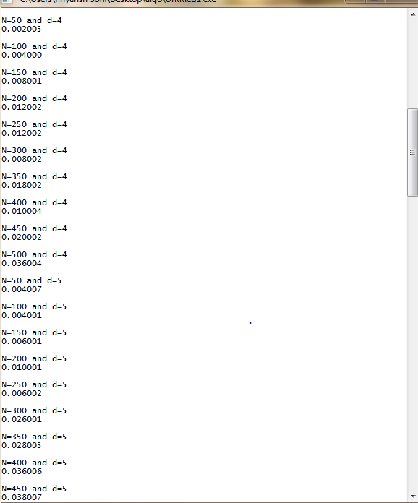

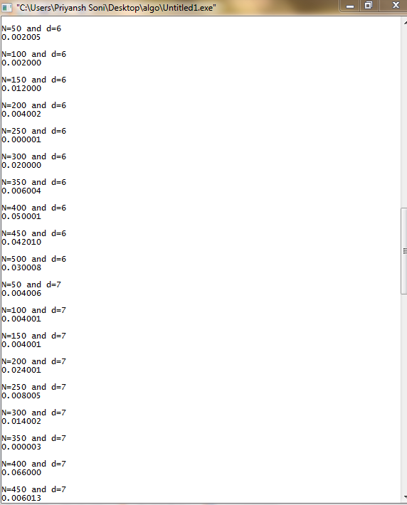

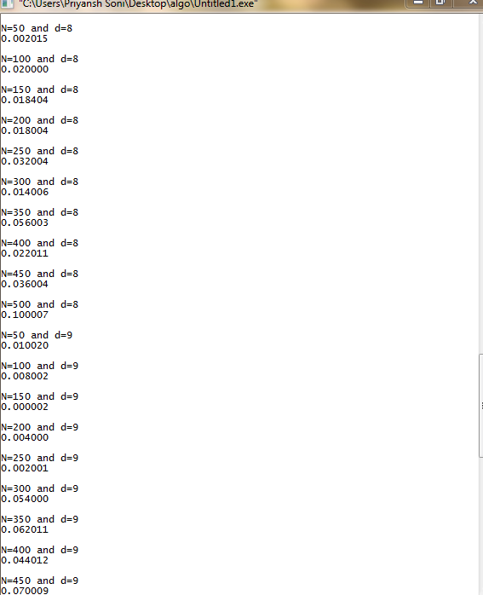

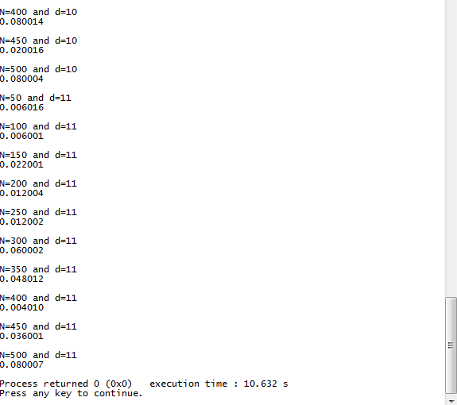

**OUTPUT FILE**

